BLOCKCHAIN TECHNOLOGY  FOR AGRICULTURAL SUPPLY CHAIN

In this project we are using IOT network and Blockchain security technology in agriculture food supply chain. In propose work IOT network will be setup in agriculture farms and this IOT will sense food quality growing farms and then report to its nearest cluster head and cluster head will report to base station. Base station will collect food quality data from Cluster Head and then store that data in decentralized Blockchain nodes. This data can be access by various users such as distributors, suppliers, farmers and consumers to know the quality of the food.

All existing techniques were using centralized server (single main server) to store data and if this server hack by malicious users then they can easily alter data on that servers and user’s may get wrong or fake data and there is no proper software to detect that alteration and to overcome from this problem Blockchain technology has been introduced. Blockchain support decentralized (data stores at multiple nodes) storage and each node will store data as block of transaction by associating each block with hash code and whenever new data arrive for storage then all nodes will verify hashcode of existing blocks and if all nodes contains same hashcode then data will be consider as secured and unaltered and then new block will be added. If any node report incorrect hashcode then that node consider as attacked and then collect data from genuine nodes. Above verification of hashcode is consider as PROOF OF WORK.

Above Blockchain technology helps in detecting attack nodes and make data secured.

In propose work we are using IOT networks and this IOT network consists of following operations

1. Generate Network: using this module IOT network will get setup
2. Cluster Head Selection: all IOT networks exchange there available battery power and then check which IOT covering more number of nodes and can reached to base station with less energy consumption then that node will be elected as cluster head.
3. Collect Data: using this module IOT will collect/sense food data from agriculture farm.
4. Data Transmission Routing Phase: using this module IOT will find shortest path to reached cluster head and then transfer data to selected cluster head. CH will send data to base station. Base station will collect data and then store in Blockchain node. Blockchain store each data as block of transaction and will generate hashcode for verification
5. View Blockchain Data: various users such as consumer, farmers, distributors and many more users may use this module to retrieve data from Blockchain and view it.

In this project they have used IOT sensors and agriculture field but we don’t have any sensors so we built this concept as simulation.

SCREEN SHOTS

To run project double click on ‘run.bat’ file to get below screen

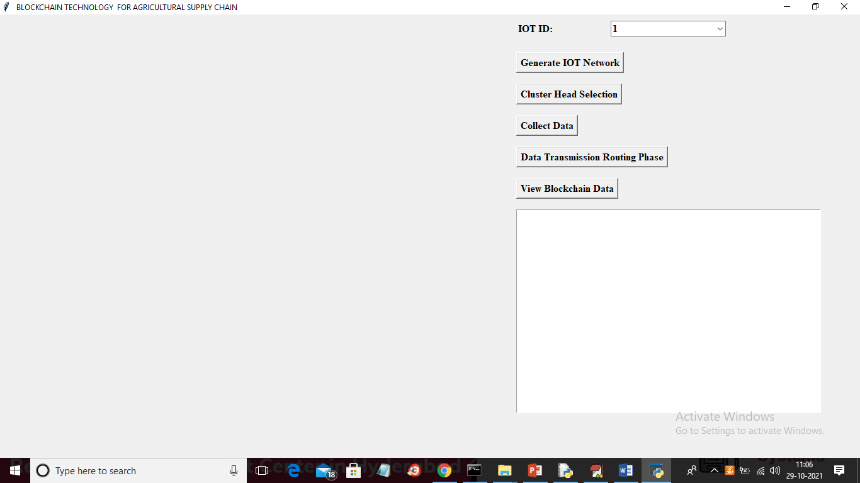

In above screen click on ‘Generate IOT Network’ button to generate IOT simulation network and to get below screen

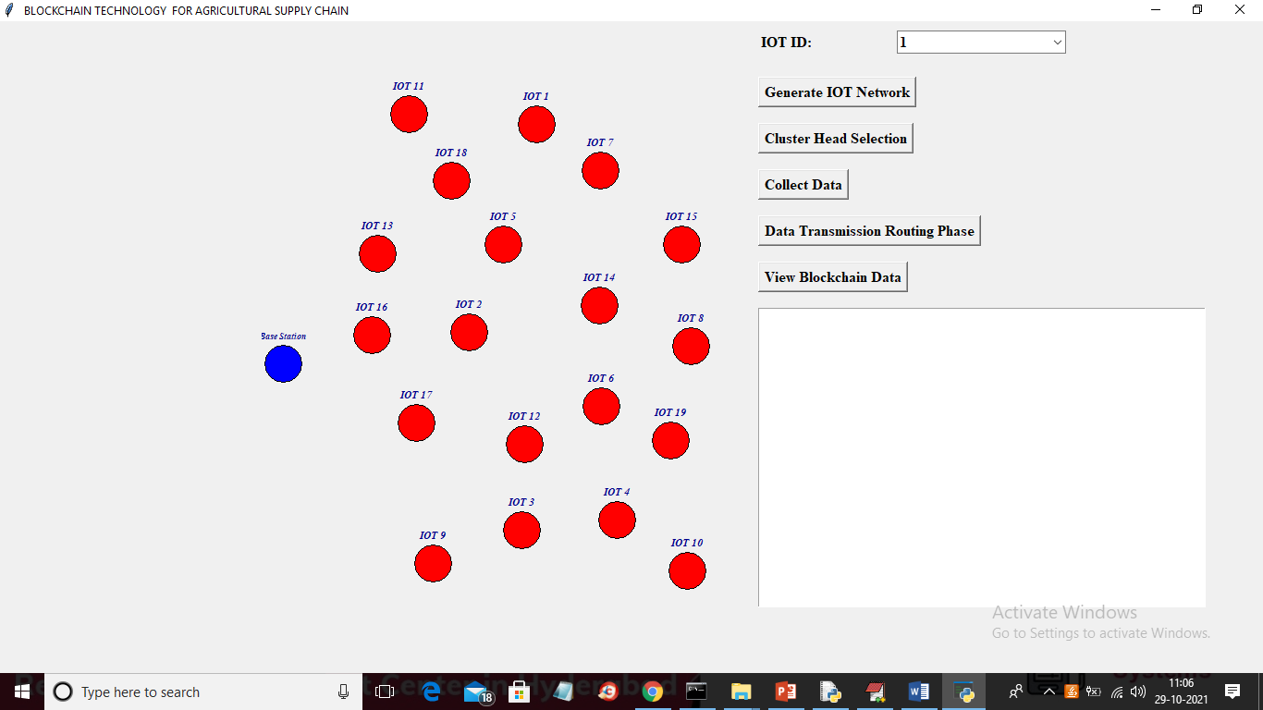

In above screen each red colour circle represents as IOT sensors installed in agriculture farms and blue colour circle represents Base Station. Now click on ‘Cluster Head Selection’ button to select cluster head with high available energy and can reach to more IOT with less distance to Base station

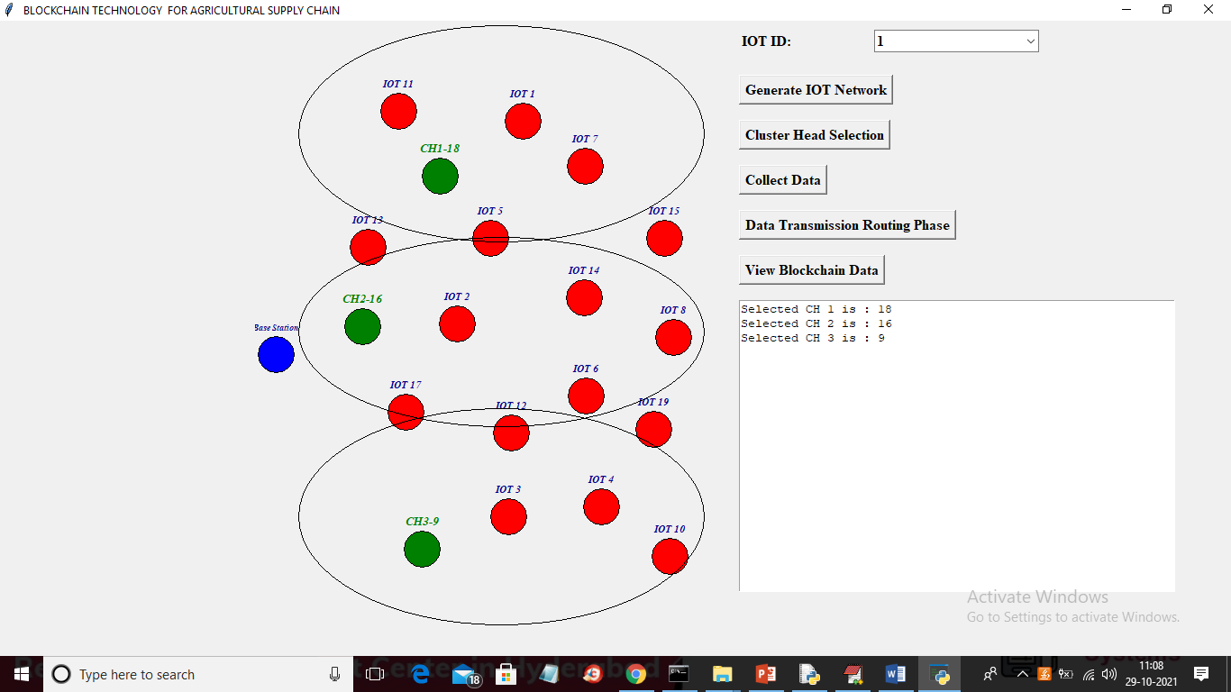

In above screen green colour IOT is selected as Cluster Head and all the IOT inside big oval will be consider as cluster member of that cluster and total 3 clusters are generated and now click on ‘Collect Data’ to enter some manual data as we don’t have any sensor to sense data so we collect data from keyboard manually

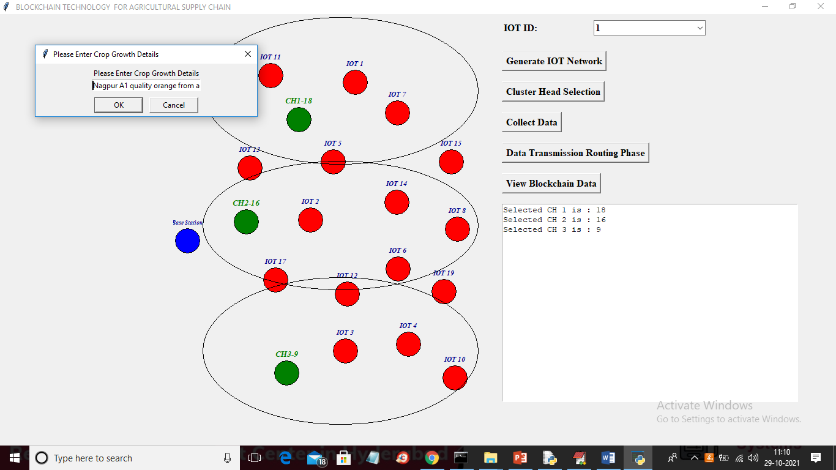

In above screen as data collection I entered some data and then click on ‘OK’ button to get below screen

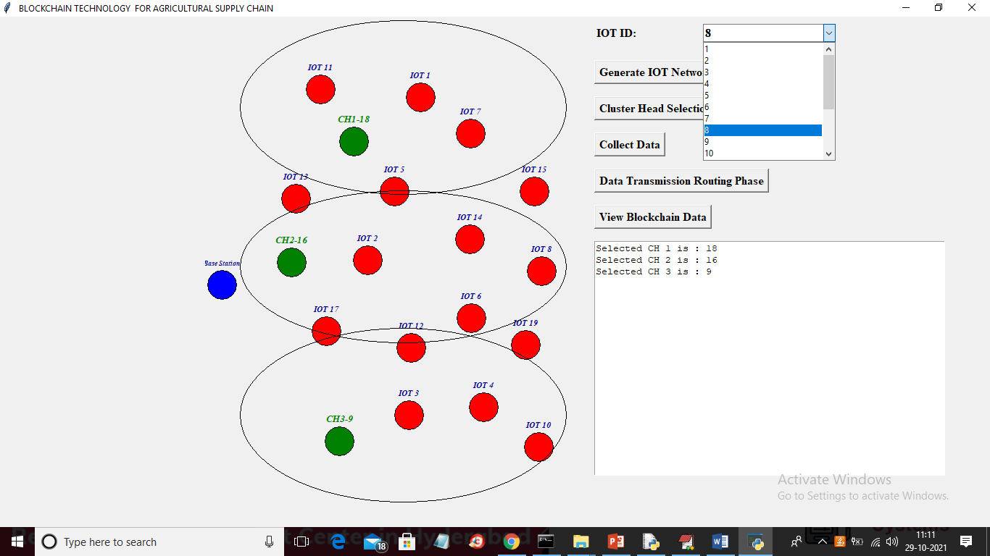

In above screen from IOT drop down box I selected sender IOT as 8 and then click on ‘Data Transmission Routing Phase’ button to allow IOT 8 to select shortest path to reached cluster head and then transfer data

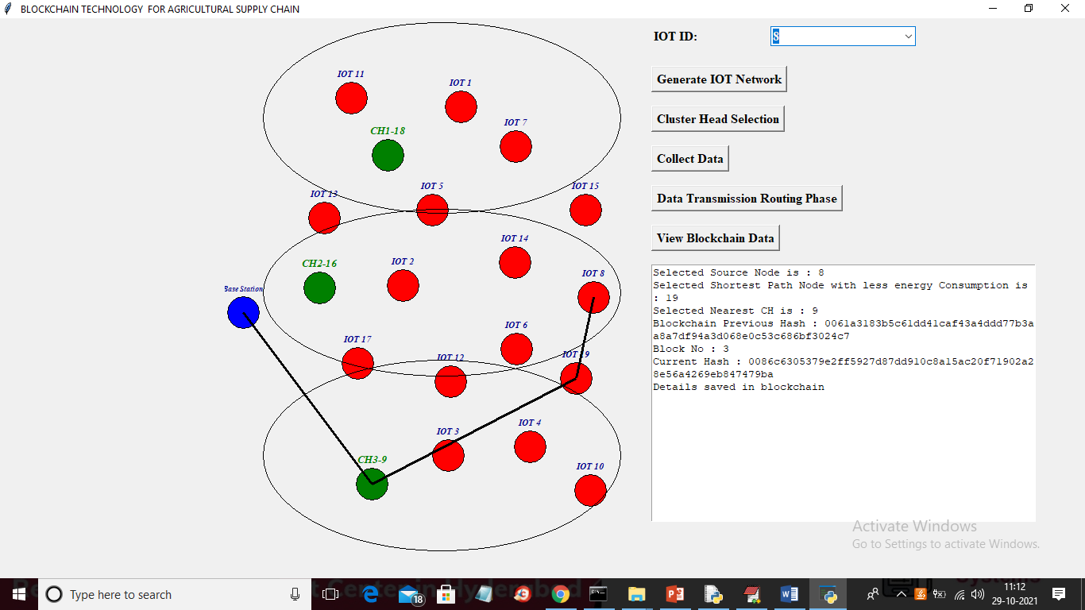

In above screen IOT 8 selected nearest hop as 9 and that 9 belongs to CH3 so it send data to CH3 and CH3 is sending data to base station and similarly you can select any IOT and then transfer data

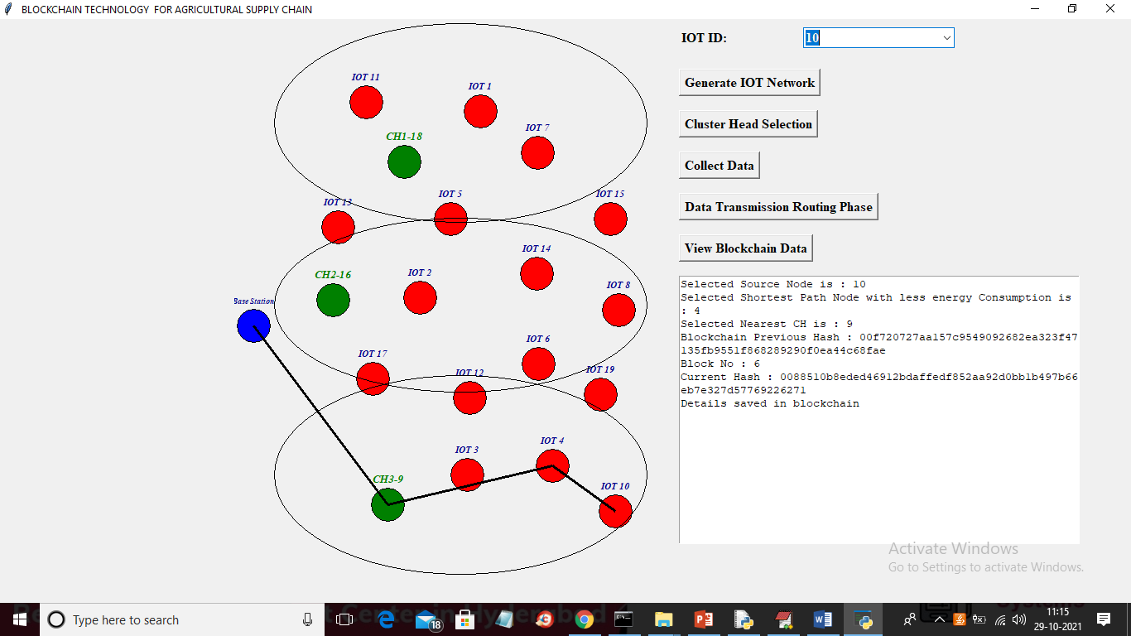

In above screen I selected IOT 10 and then it select CH 3 to send data to base station and in above screen we can see each data is stored at Blockchain and each block associated hashcode is also displaying and now select any IOT and click on ‘View Blockchain Data’ to extract data from Blockchain for selected ID

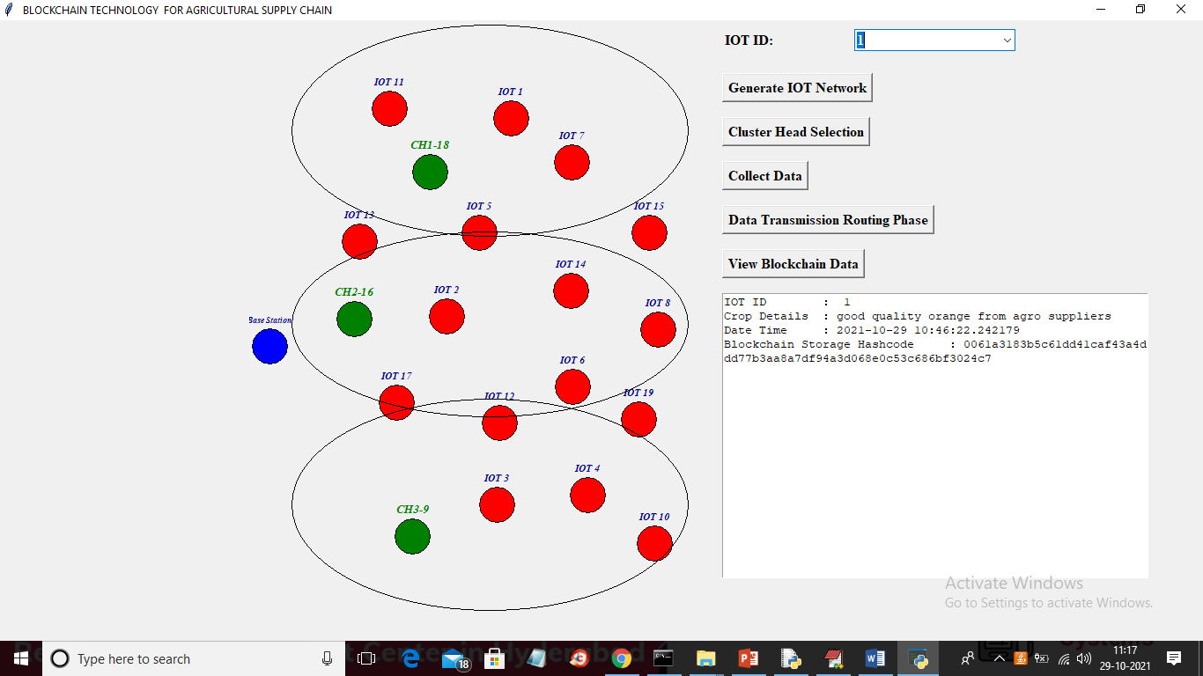

In above screen I selected IOT as 1 and then clicked on ‘View Blockchain Data’ button and then in text area all data for that IOT retrieve from Blockchain and then displaying and I am displaying hashcode of that block.

Below screen showing code for Blockchain implementation

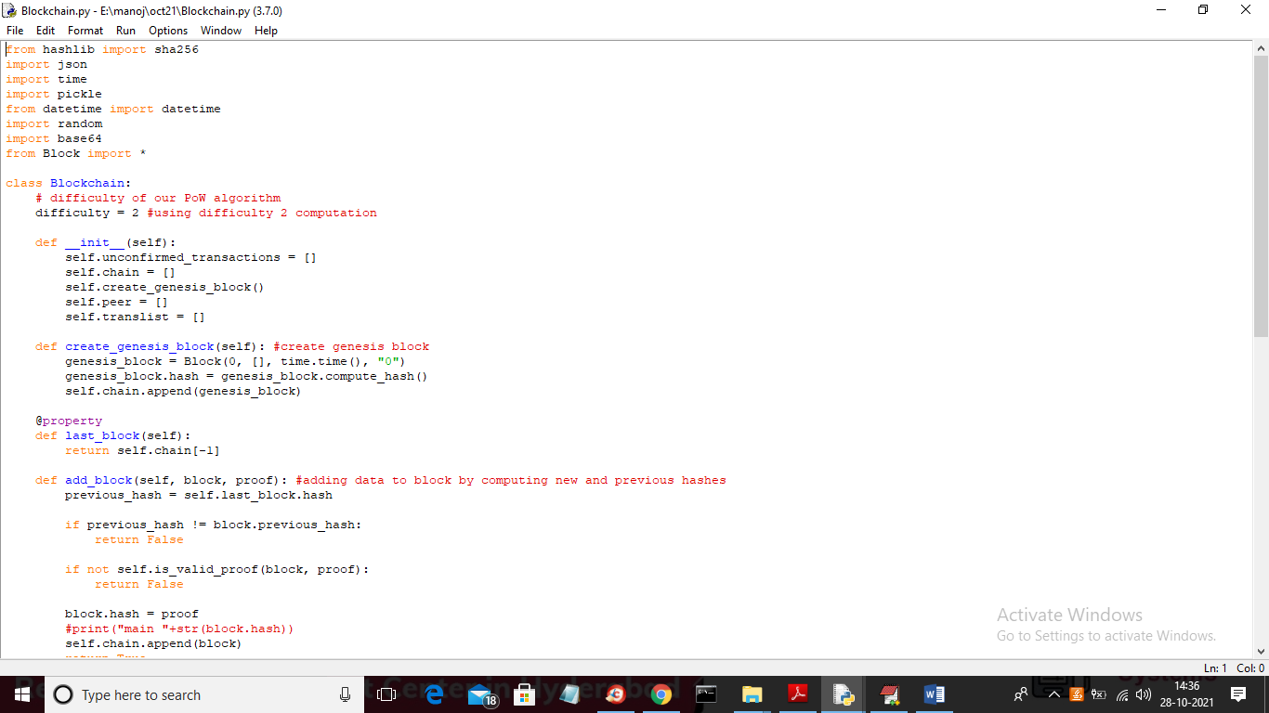

In above screen read red colour comments to know about Blockchain transaction storage

